TEMPLATE O-5
Revised December 19, 2022

Agency Name
Transit Policies and Procedures

Subject | Brochures
Section | Outreach
Effective Date
Approved By
Approval Date

Purpose

Create a concise marketing document that summarizes agency transit service information.

Procedure

Develop a brochure that can be used to reach prospective passengers. The brochure should display a picture or artwork of public transportation and should include the following information:

- Agency name, address, and phone number
- Service hours
- Service area map or description
- Fares and discounts
- List if exact fares are required
- General policies
  - Personal Care Attendants (PCA) ride free.
  - Children aged 12 and under must be accompanied by an adult.
  - Parents must supply & install child safety seats.
  - Seat Belt Policy
  - Service animals are permitted.
  - Pets are required to be in a kennel.
  - List Parcels Policy
  - Restricted items are not allowed.
  - List No Show Policy
  - List Pick-Up Window
  - List assistance driver will or will not provide.
  - List how to schedule a ride - Must they be scheduled 24 hours in advance, do you do same day rides, do you do flags stops.
- Website address for the Rider’s Guide / Passenger Handbook / Service policies
- List Funding Sources
- Reasonable Modification
- The brochure should state that the information is available in alternate formats such as large print, audio, or electronic file.

The brochure should also be posted on the Agency’s website along with any other polices which effect the passenger or general public.

Responsibilities

The Transit Director is responsible for coordinating the development and distribution of a customized brochure.

Example

See attached template.

This policy or procedure is intended to be used as an example. It should be customized to each transit agency. Review by a legal expert is recommended.

Mission Statement
The Agency’s mission is to provide safe reliable transportation for all users throughout our service area.

General Policies
- Personal care attendants ride free.
- Children age 12 and under must be accompanied by an adult.
- Parents must supply and install child safety seats.
- Service animals are permitted.
- Pets are required to be in a kennel.
- Parcels are limited to five grocery bags or small packages under 10 pounds each.
- Restricted items are not allowed.
- List No-Show Policy
- List Pick-Up Window
- List assistance driver will or will not provide.
- List how to schedule a ride - Must they be scheduled 24 hours in advance, do you do same day rides, do you do flags stops.

Contact Information
Agency Name Address
City, State Zip Code
Phone: (XXX) XXX-XXXX
Email: Agency Name
Visit our website for more information and to access our Rider’s Guide:
www.XXX.com

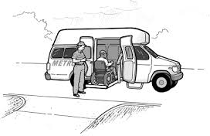
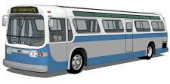
In accordance with the Americans with Disabilities Act (ADA) and directives from the Federal Transit Administration (FTA), XXX Transit will make every effort, to the maximum extent feasible, to ensure that a person with a disability has access to, and benefits from, its services. XXX Transit will make reasonable modifications to its policies, programs, and procedures applicable to its transportation services when necessary to avoid discrimination and ensure accessibility for people with disabilities. To access the full Reasonable Modification Policy or to request a reasonable modification based on a disability, please use the Reasonable Modification Request Form located on our website or by contacting XXX Transit at (XXX) XXX-XXXX. All Reasonable Modification Requests must be

submitted a minimum of 24 hours in advance.

This information is available in alternate formats such as large print, an electronic file or an alternative language upon request.

Call to schedule a ride:
(XXX) XXX-XXXX

Service Area
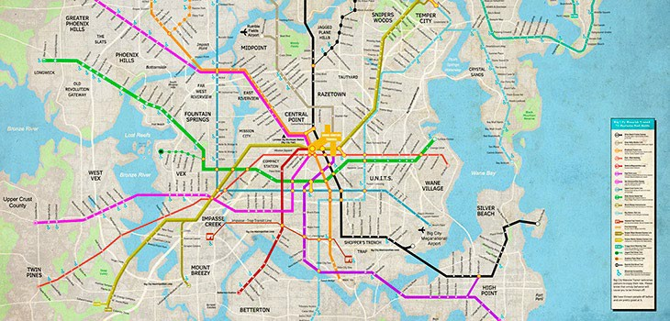

Transit services may be limited or temporarily halted during events such as inclement weather, natural disasters, or health pandemics.

Transit Service Destinations
- Employment venues
- Medical facilities
- Pharmacies
- Senior centers
- Grocery stores
- Community centers
- Destination of your choice within service area.

Hours of Operation
Transit services will operate Monday through Saturday during the following hours:
Monday: X:XX AM TO X:XX PM Tuesday: X:XX AM TO X:XX PM
Wednesday: X:XX AM TO X:XX PM Thursday: X:XX AM TO X:XX PM Friday: X:XX AM TO X:XX PM
Saturday: X:XX AM TO X:XX PM Sunday: No service

Holidays
The Transit System will be closed in observation of the following holidays:
- New Year’s Day
- Memorial Day
- Independence Day
- Labor Day
- Thanksgiving Day
- Christmas Eve (limited service)
- Christmas Day

Fares

General Public | $X.XX per one-way trip
Elderly and Disabled | $X.XX per one-way trip
Children 17 years of age and younger | $X.XX per one-way trip

Drivers do not carry money. A ticket or exact fare is required.
Elderly and disabled passengers must complete an application form to qualify for reduced fares.
A parent must accompany children being transported to a childcare facility. If a parent is transporting multiple children to a childcare facility, only one child fare
will be charged.

Funded by:

FTA 5311 Grant Program administered by ALDOT

XXX County Commission

